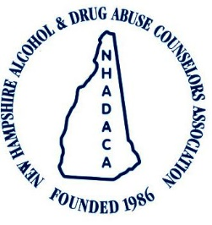

The NH Training Institute

on Addictive disorders

Presents:

Teen Culture
with Marissa Carlson
A 6-hour training event on December 3, 2021
1 Hour Webinar Training

PRESENTATION: Want to know more about the cultural forces that impact the teenagers you work with, positively and negatively? Do you ever feel a little behind the times when hearing your students talk about their favorite shows, websites, or bands? Through survey results, live web exploration, and other presentation materials, this webinar will provide overviews and insight about the interests, activities, and other age-related cultural influences of today’s teenagers in NH, New England and beyond. As a result of this training participants will:
- Increase their knowledge about the pop culture media trends, including music, TV & web shows, and books, with a regional and US focus.
- Explore some of the websites and apps most popular with high school students.
- Gain further resources for information on cultural trends they learn about in the future.

PRESENTER: Marissa Carlson, CPS is the Executive Director of the NH Teen Institute, a leadership development non-profit working with middle & high school students from around NH & New England in a variety of areas including substance abuse prevention, peer mentoring, and creating positive school & community climate. She has been a Certified Prevention Specialist since 2011 and, as part of her role at TI, oversees and facilitates training for both the youth participants and TI’s youth & adult volunteer program staff. Outside of her work with TI, Marissa is the Associate Artistic Director of Mill City Productions, a theatre company in Western Massachusetts.
Registration Fee: *NHADACA Members: Free *Non-Members $15.
For registration information contact: 603-225-7060, training@nhadaca.org
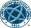
1 Contact Hours Available
Certified Prevention Specialist Domains: 2, 3 & 6
LADC/MLADC Categories of Competence: 5, 13 &15
CRSW Performance Domain: None
NBCC: LICSW/L-MFT/LCMHC (Category 1) & Psychologist (Category A) NH Alcohol & Drug Abuse Counselors Association has been approved by NBCC as an Approved Continuing Education Provider. ACEP No 6754. Programs that do not qualify for NBCC credit are clearly identified. NHADACA is solely responsible for all aspects of the program.
Schedule

On-demand

